WELL-KNOWN BOREHOLES

“ST10352114 – Muhammed Safwaan Ally – WEDE5020 – POE – Part 1.pdf”

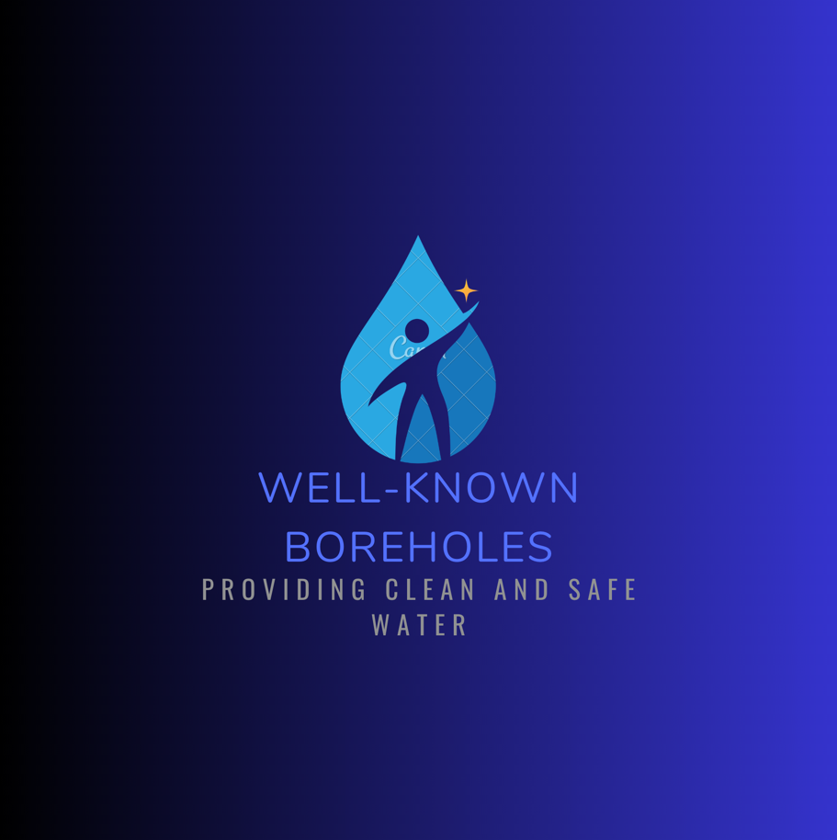

Contents:

1. About us – Page 3
2. Logo – Page 4
3. Images – Page 5
4. Assets – Page 6
5. Website Pages and Content – Page 7

About Us:

Our goal is to drill boreholes in order to supply communities in need with clean and safe water. At Well-Known Boreholes, we want everyone to have access to clean and safe water, which will enhance their health and standard of living. Our goals are to build boreholes in regions where there is a lack of access to drinkable and safe water, to educate communities on conservation practices and hygiene and to work with other groups to increase access to water in impoverished regions.

Here at Well-Known Boreholes, we will take part in a variety of activities. Here are a few of the things we will do. identifying regions in need of boreholes through conducting feasibility studies, seeking money to sponsor programs to build boreholes, identifying ideal areas for boreholes through working with local governments and people, the creation of boreholes, the installation of pumps and associated apparatus, By promoting awareness of water conservation and hygienic procedures, Peoples in rural areas without access to clean and safe water are the target demographic for monitoring and maintaining boreholes to ensure their sustainability and lifespan.

Our NGO's first geographic focus will be on communities in Africa, with the possibility of later expanding to other areas. With regards to financing Well-Known Boreholes will look for funding from private individuals, business partners, and other associations that support our goals. By giving the proceeds from the sales of the fresh, pure water we bottle from the boreholes we install, this means we have a special way of getting funds from individuals in a retail environment.

Community leaders, water and sanitation agencies, corporate partners and hopefully a thriving philanthropist such as Bill gates or Peter Jones with similar values and goals will be some of our NGO's most important partners. Leadership and governance are as follows: A board of directors made up of experts in finance, community development, and water and sanitation will be in charge of Well-Known Boreholes. The executive director, who will be responsible for managing the organization's daily activities, will be chosen by the board.

Logo:

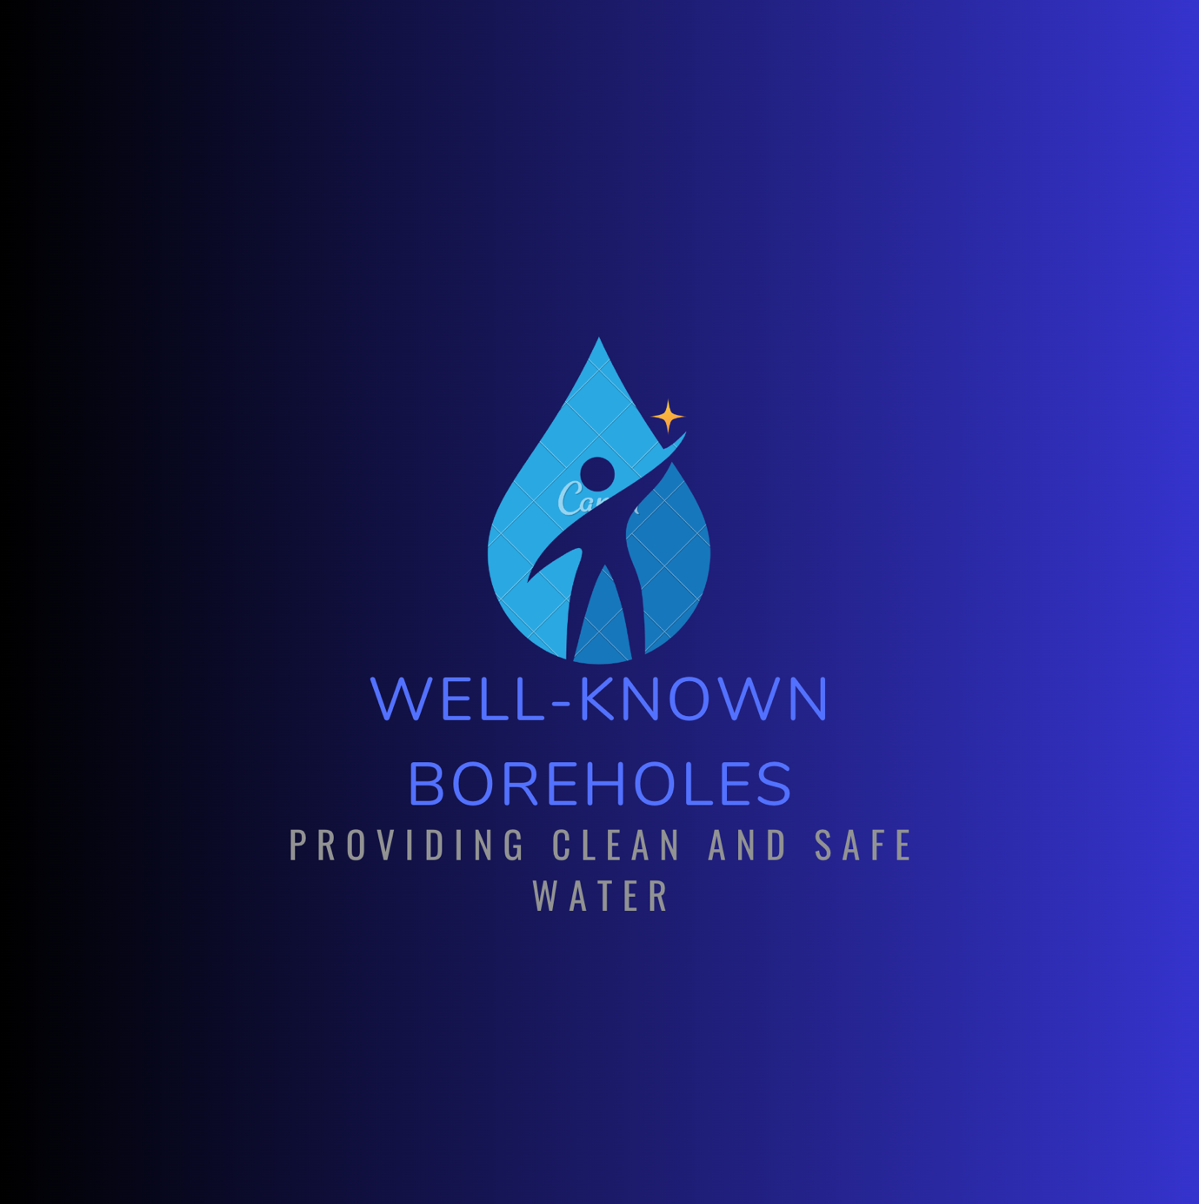

Images:

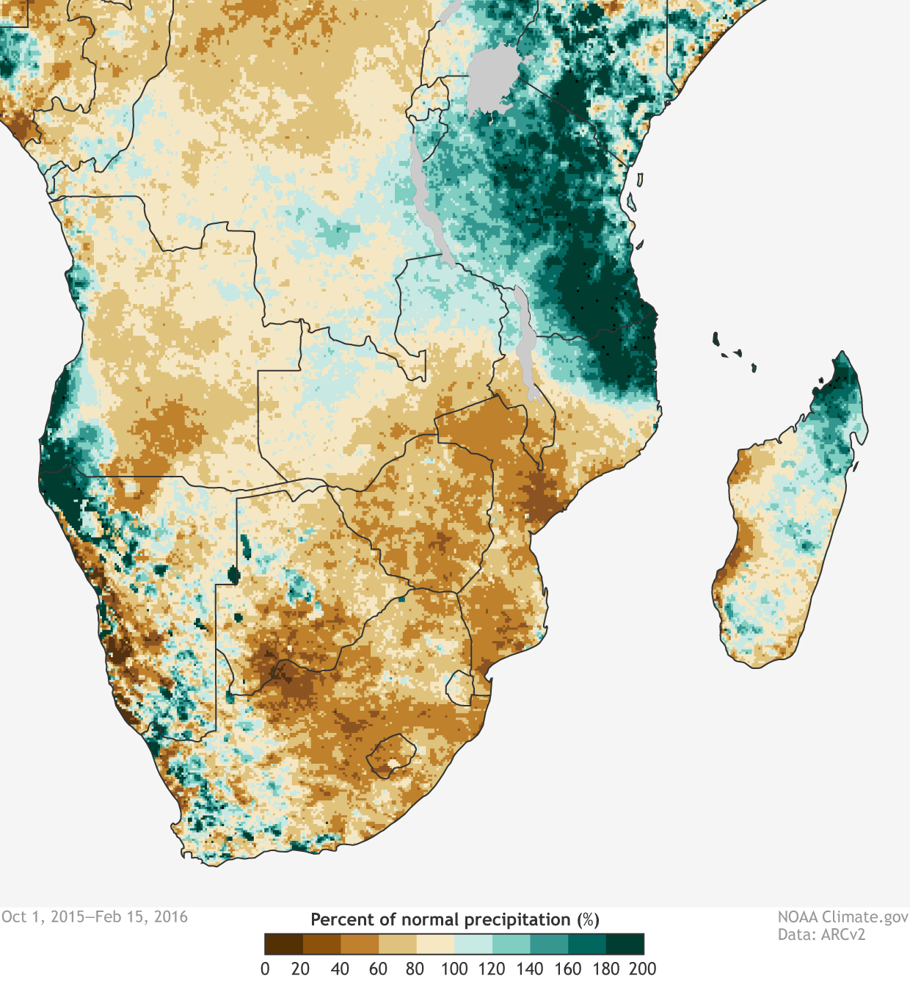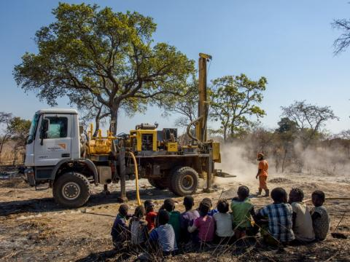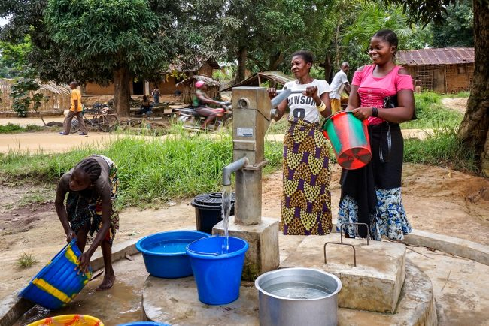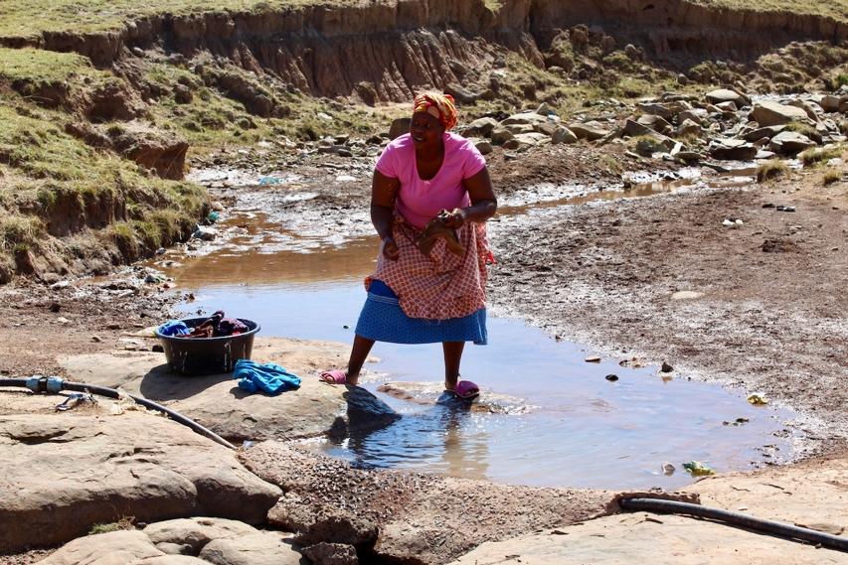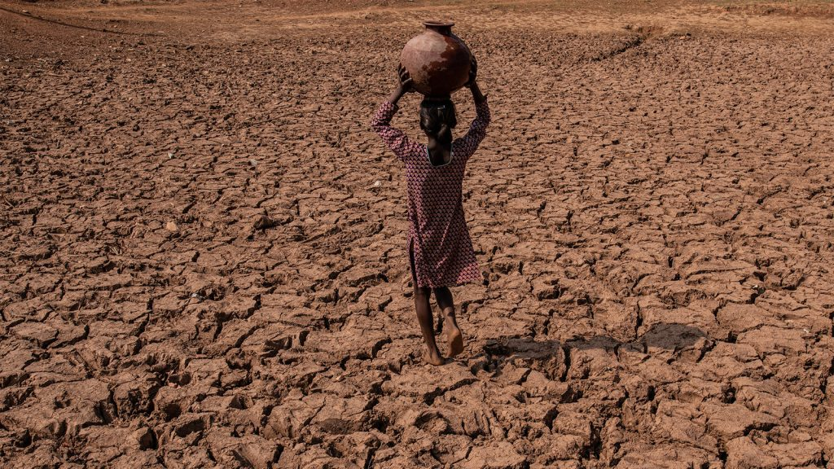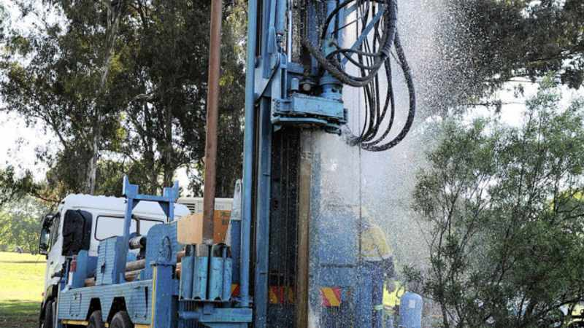

Assets:

allafrica.com

World Health Organization

Canva Logo

<https://www.iol.co.za>

<https://www.who.int/>

Website Pages and Content:

1. Homepage:
2. Logo
3. Slogan
4. Links to other pages
5. Extremely brief Summary of activities and purpose of NGO
6. Name of Organization
7. About us:
8. Information of what we do as an NGO.
9. Contact Page:
10. Name of NGO
11. Social Media links and phone numbers
12. Our work:
13. Outline of NGOs work and activities
14. Logo
15. Images of NGO work
16. Gallery:
17. Images of NGO work